- Purpose

This procedure shall be followed when switching from the primary to the secondary air compression system in the plant for maintenance purposes or because of down time in the plant.

- Scope

This procedure applies to all maintenance workers

- Responsibility

Maintenance, Material Handlers, and Lead Operators are responsible for knowing the procedure to transfer the plant from primary to secondary air production.

- Safety Considerations

Safety glasses and appropriate safety apparel is to be worn at all times. This includes wearing the appropriate protection for working at heights above six feet.

Safety is a condition of employment. Employees are not authorized to work in an unsafe manner and are prohibited from harming the environment of the facility or community.

- Materials/Equipment

N/A

- Procedure

Procedure to switch from the primary to the backup air compressor system.

- Check the menu screen on the front of the #1 Air Compressor as shown below. Then press the unload button which will take the compressor below 75 PSI if it is not already. Then press the off button on the menu screen to cut the compressor off. 75 PSI
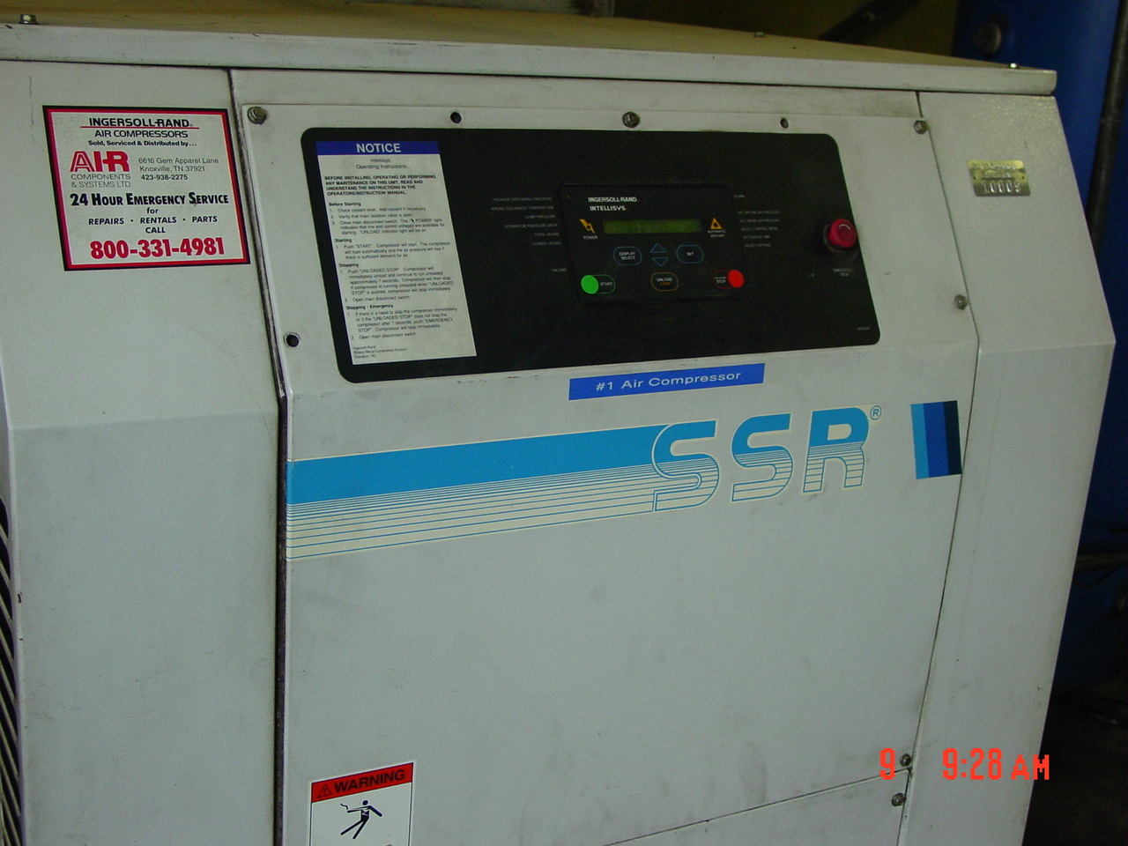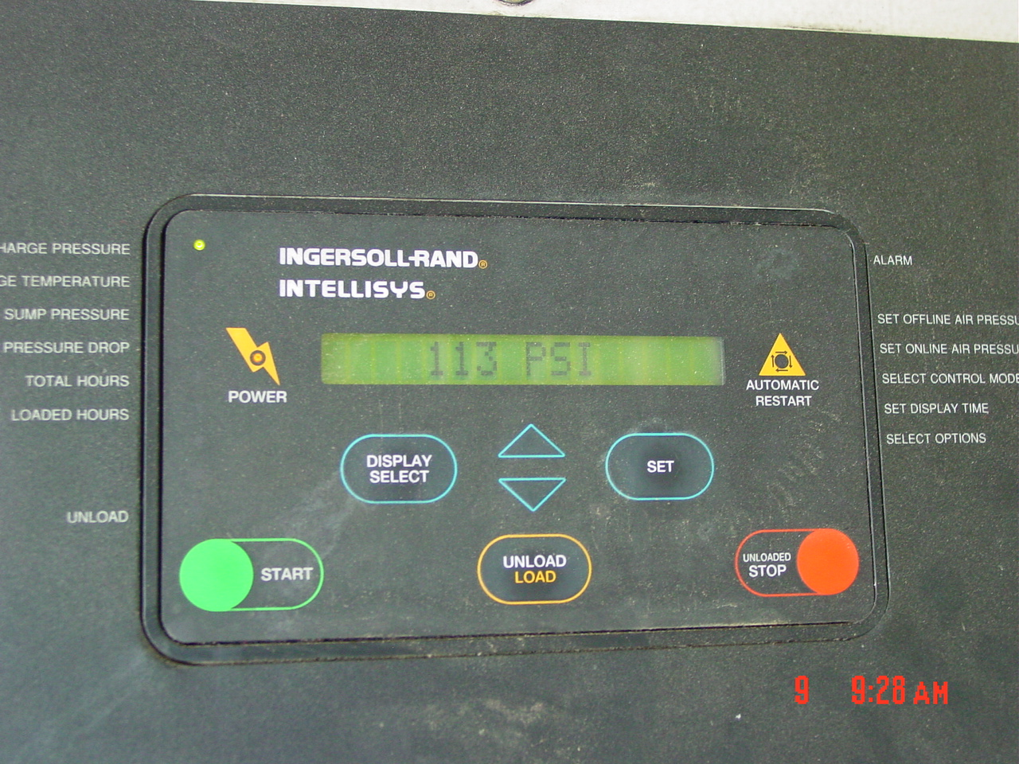

- Next step is to switch the air supply from the #1 Air Compressor to the #2 Air Compressor. This is accomplished by cutting the air off the primary air compressor (valve #1) and cut air on to the second air compressor (valve #2) as indicated below. These valves are located in the ceiling above the compressors.

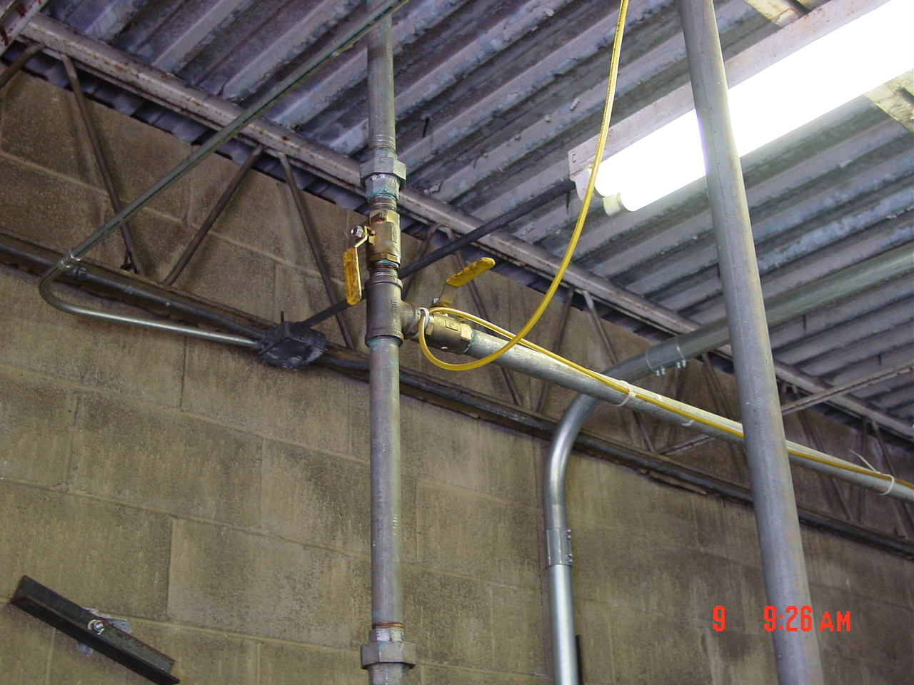

- Third step is to confirm the power is off to the primary air compressor and initiate power to the backup system using the disconnect located on the wall directly beside the #2 Air Compressor.
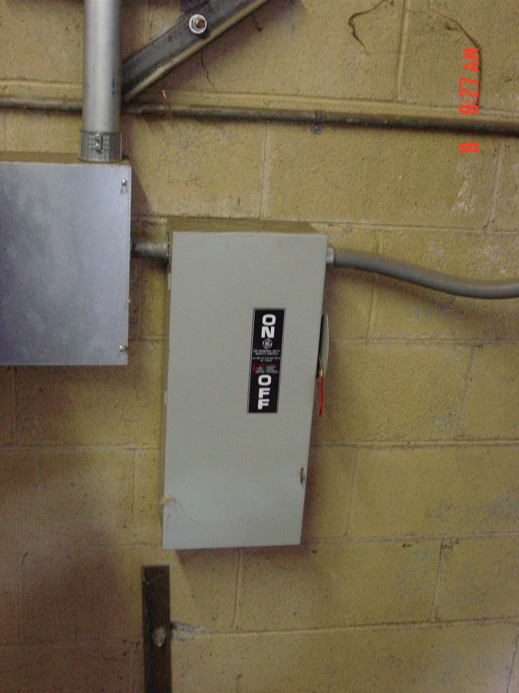

4. Initiate power to the #2 Air Compressor using the control panel on the compressor as indicated below:

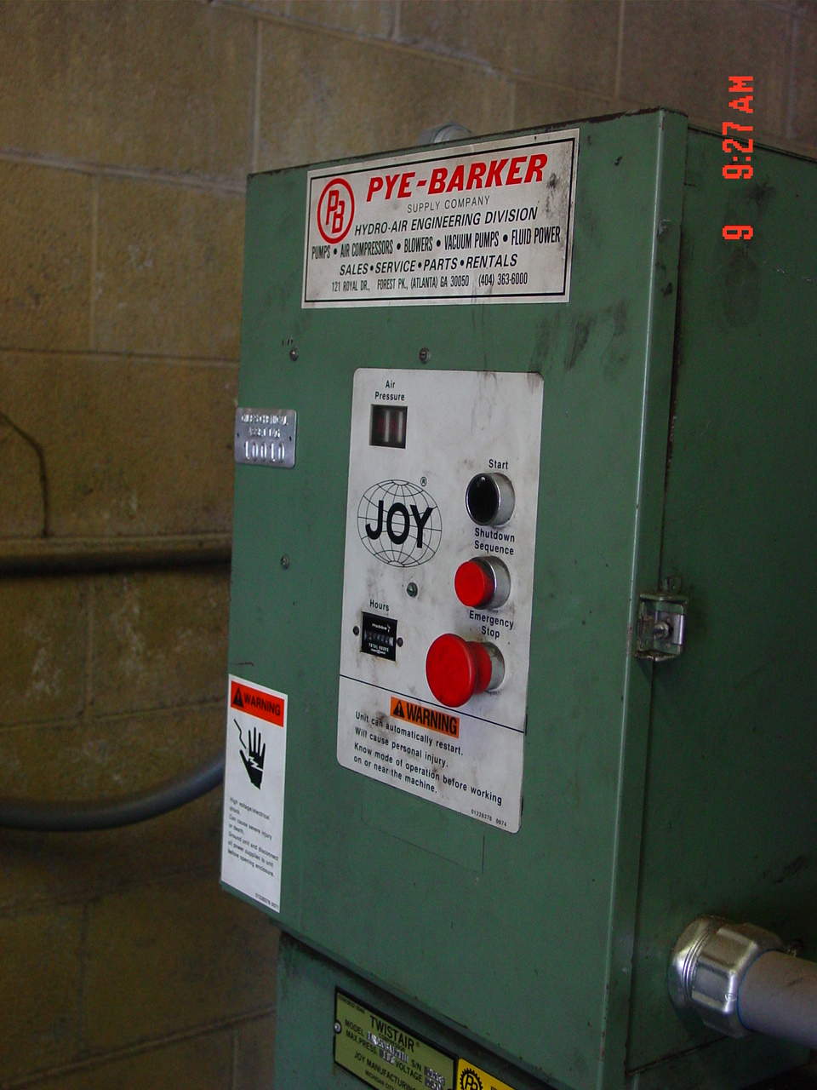

Backup system should be up and running. Maintenance should be the only ones who switch back to the primary air compressor once maintenance is complete and/or breakdown is repaired.

- Reference Documents

N/A

- Amendment Record

Document review- updated format using new template and numbering system.

